Leibniz’s Theorem

- If 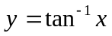 then show that

- If 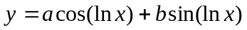 then show that 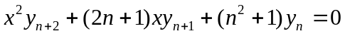

- If 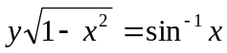 then show that 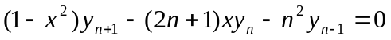

- If 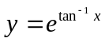 then show that

- If 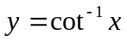 than show that

- If 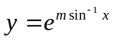 then show that

- If 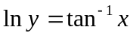 then show that
[Q#7 is Same as Q#4]

- If 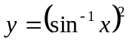 then show that 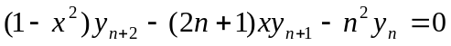

- If 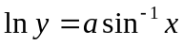 then show that

- If 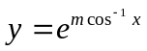 then show that

- If 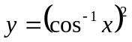 then show that

- If 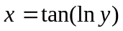 then show that
[Q#12 is Same as Q#4, Q#7]

- If 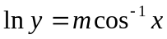 then show that
[Q#13 is Same as Q#6]

Indeterminate form

Evaluate:
1. 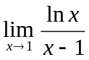 2. 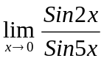 3. 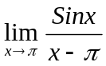 4. 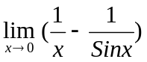

5. 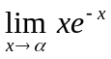 6. 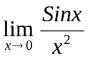 7. 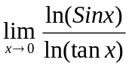 8. 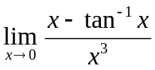
9. 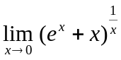 10. 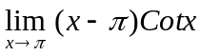 11. 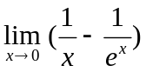
12. 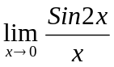 13. 

